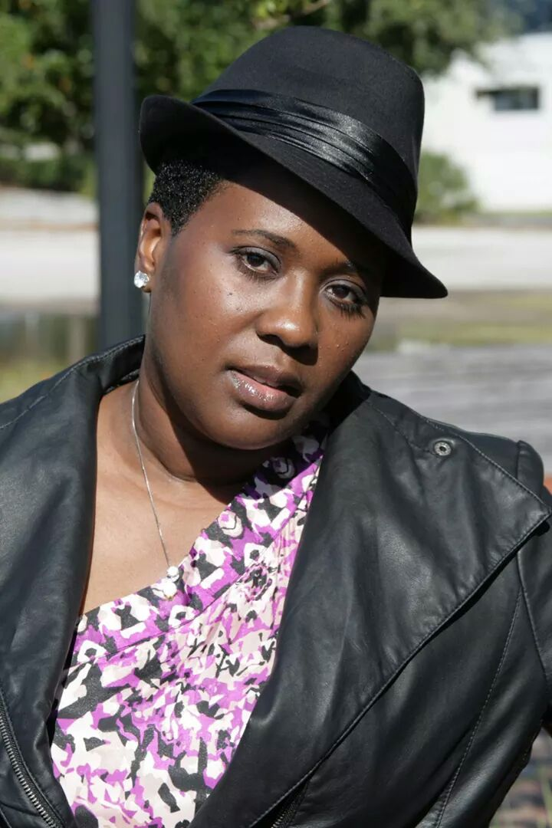
Tanya Haynes-Cummings
Born in Riviera Beach Florida
Graduate of Edward Waters College B.A. Communications
904-993-7220
mstanentertainment@gmail.com
Terry Nicholas Productions
My Brother’s Keeper Ms. Linda the (Bad mom- Diva) stage play
A Will to Live Yenetta Stevens (Aggressive Lawyer) stage play
BeDynamik Productions
David Died Today Ms. Charlotte (Mom/Grandmother) short film
BeDynamik Diane (Character with Aids) stage play
Stage Aurora
The Colored Museum Topsy Washington (Energetic Party Girl) stage play
Steel Magnolias Truvy Jones (Hair Salon Owner, Sassy and Caring)
Z Jones Productions
Love and Betrayal Michelle (Very Outgoing and in love) stage play
Can I Have My Spouse back Michelle (Woman Age 35 conservative) who is controlled by her mom
D Destiny Productions
A Heart That Forgives Laniya (Woman age 30- 35 spoiled Diva) 2 hr. Film
Duval The Musical Janet - (A woman with multiple personalities)
Heterow’s Closet Naomi (High Powered Lawyer brought down to humbleness)

I am, a Mother, Actress, DJay ,Host, Party Planner, Jingle Writer and Motivator!
My interest includes djaying ,acting , traveling, and reading .
Thank you for your time and consideration!

